T.PRANEETHA
192412588
ECA3102
NANO ELECTRONICS

Exp. 3. Kronig Penney Model
Case Study 1: Simulate the output for Triangular well
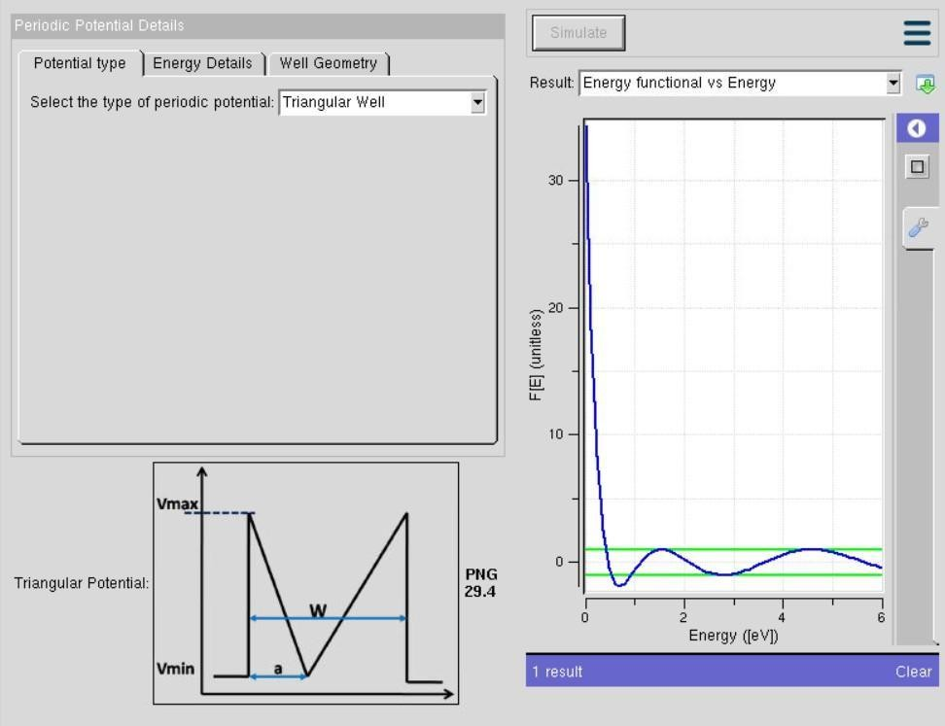
In this simulation, the periodic potential is modeled as a triangular well. The graph shows how electrons experience confinement in a gradually varying potential rather than abrupt barriers. This smoother potential profile leads to narrower band gaps compared to square wells, since the electron wavefunctions overlap more strongly across the lattice. The triangular well highlights how the shape of the potential influences the effective band structure, producing less sharply defined energy bands but allowing easier tunneling between states.

Case Study 2: Simulate the output for Sinusoidal Potential
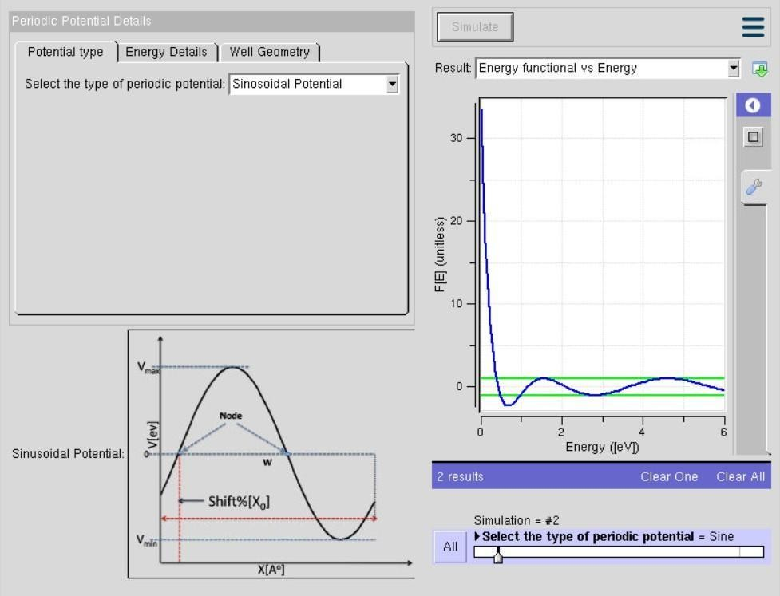

In this simulation, the periodic potential is modeled as a triangular well. The graph shows how electrons experience confinement in a gradually varying potential rather than abrupt barriers. This smoother potential profile leads to narrower band gaps compared to square wells, since the electron wavefunctions overlap more strongly across the lattice. The triangular well highlights how the shape of the potential influences the effective band structure, producing less sharply defined energy bands but allowing easier tunneling between states
Conclusion
The simulation shows that the triangular potential well provides smoother electron confinement, resulting in a smaller band gap and easier electron tunneling. This confirms that the shape of the potential well significantly affects the electronic properties.

